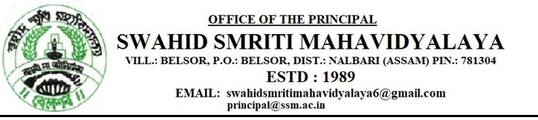
Ref.No. Date: 17.11.2022

400th Birth Anniversary Celebration Programme of Lachit Barphukan
Swahid Smriti Mahavidyalya

- 19th November 2022 – Essay competition

- 20th November 2022 – Tree plantation.

- 21st November 2022 – Drawing competition.

- 22nd November 2022 – Quiz competition.

- 23rd November 2022 – Speech competition.

- 24th November 2022 – Garlanding the portrait of Lachit Barphukan and the
Celebration meeting of 400th centenary birth anniversary of Lachit.

