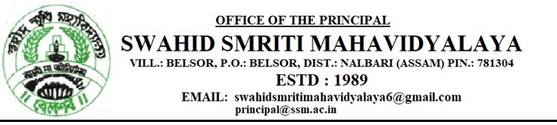Ref.No. Date:30.10.2023

NOTICE

It is for general information to all the students, faculty members, non-teaching staff and library staff that India is celebrating Rastriya Ekta Divas from 25th October to 31st October 2023. The Swahid Smriti Mahavidyalaya is also celebrating Rastriya Ekta Divas 2023 as per order of the DHE. All are requested to extend cooperation in this regard. Following faculty members are engaged to arrange different programme as per order of Govt of Assam.
- Mr. Biswajit Baishya, Assistant Prof. (T). Dept of Pol. Sc, Swahid Smriti Mahavidyalaya.
- Mr. Pradip Kalita, Assistant Prof. Dept of Education, Swahid Smriti Mahavidyalaya.

Dr. Manash Barthakur
Principal
Swahid Smriti mahavidyalaya
