NOTICE

It is for general information for the B.A. first semester students that their Viva of Spoken English will be held on 24.01.2024 (Wednesday) at 10.30 AM onwards. All are requested to be present at college without fail. It is compulsory for all.

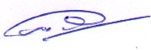
Bipul Kr Das
HOD of English
Swahid Smriti Mahavidyalaya

