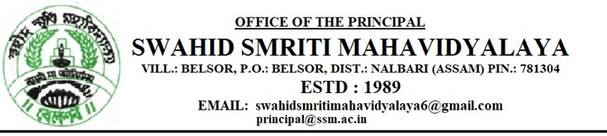
Ref.No. Date: 13.12.2022

Request for Quotation

Sealed Quotations are hereby invited from eligible and resourceful enterprise or firm.
Quotation submission due date: On or before 20/12/2022 Time: 03.00 PM
Late Quotation shall be rejected.
Work Description
SI | Items | Product Description |  | Quantity | Rate | Total
1 | Steel Almirah | Steel & Style , Modi, Godrej |  | 1 nos
2 | Property counter | L- 5” , H- 6” | 1 nos
3 | Computer Table with box | L- 3” , W- 2.5” | 1 nos
G. Total =
N.B. – Library Committee’s decision is final.
For Terms and Conditions contact College Office
Email : principal@ssm.ac.in
swahidsmritimahavidyalaya6@gmail.com

Sincerely
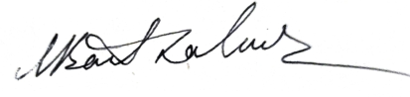
Dr. Manash Barthakur
Principal
Swahid Smriti Mahavidyalaya
