Ref.No. Date: 04.11.2022

Request for Quotation

Sealed Quotations are hereby invited from eligible and resourceful enterprise or farm.
Quotation submission due date: On or before 30/11/2022 Time: 03.00 PM
Late Quotation shall be rejected.
Work Description
SI | Items | Product Description |  | Rate per pic / packet | Total
1 | Fan | USHA/ CROMPTON/ POLYCAB
2 | Light | CROMPTON/ SYSKA/ GOLD MADEL
3 | Holder | HAVELLS/ ORIENT / GOLD MADEL
4 | Board | HAVELLS/ ANCHOR / GOLD MADEL
5 | Wire | FINOLEX / POLYCAB/ KEI
6 | Switch | GM/ ANCHOR / GOLD MADEL
7 | Transport and Installation charge | -
G. Total =

N.B. – Construction Committee’s decision is final.
For Terms and Conditions contact College Office
Email : principal@ssm.ac.in
swahidsmritimahavidyalaya6@gmail.com

Sincerely
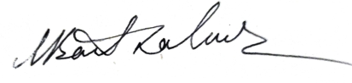
Dr. Manash Barthakur
Principal
Swahid Smriti Mahavidyalaya
